*Florida International University*

*School of Computing and Information Sciences*

Software Engineering Focus

Feature Document

ID #690 Implement Queue Interface Scene

**Name: Daniel Khawand**

**Team Member(s): Hamilton Chevez, Bernardo Pla, Pachev Joseph, Daniel Rivero**

**Project: Web VR 1.0**

**Product Owner(s)**: Francisco Ortega

**Mentor(s)**: Francisco Ortega

**Instructor**: Masoud Sadjadi

**User Story Name: Implementation of Queue Interface Scene**

* .**Description:** As a student that use this application, I would like to see a queue data structure be implemented visually, so I can understand better the queue interface.

### **Acceptance Criteria:**

1. System notifies user of Enqueue action
2. System notifies user of Dequeue action
3. System illustrates LiFo property.

**Use Case**

* Name: Queue Interface Scene
* Actor: User
* Preconditions: User must have WebGL enabled in their browser and user must click on the Queue Scene.
* Description:
* User clicks Enqueue and a box gets added
* User clicks Dequeue a non-empty queue and it makes the first box vanish
* User attempts to Dequeue an empty queue and gets an error message
* User can leave to another scene

**Use Case Diagram**

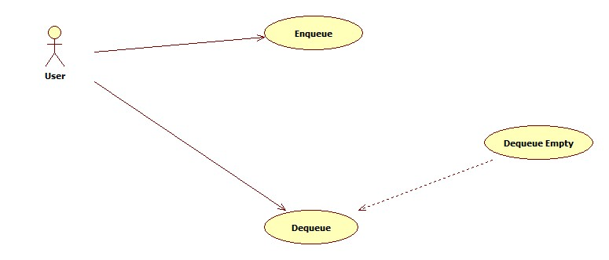

**Sequence Diagram**

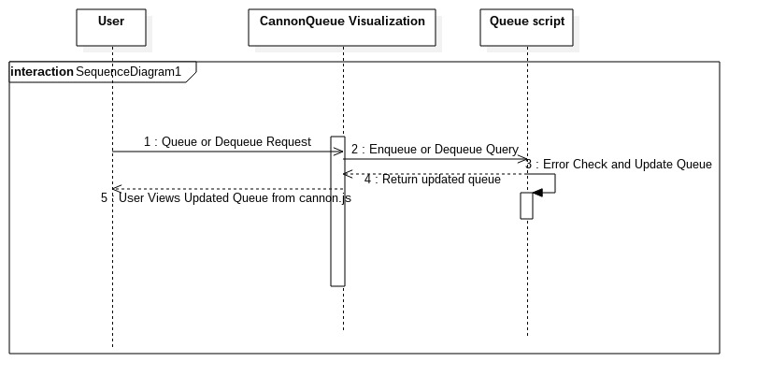

**Class Diagram**

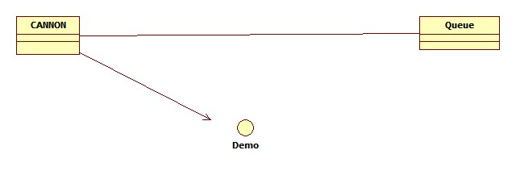

**Unit Test**

* Test case ID:
* Description/Summary of Test:
* Pre-condition:
* Expected Results:
* Actual Result:
* Status (Fail/Pass):

**Integration Test**

**Visual User Guide** <like one or two screenshots of the feature. For the hardware project, a photo of device is required>